HTML5 is the fifth and current major version of HyperText Markup Language (HTML), the fundamental language for structuring content on the web. It represents a significant evolution from previous HTML versions, aiming to provide a more robust, flexible, and feature-rich platform for web development.
Key characteristics and advancements of HTML5:
- Simplified Syntax:
HTML5 introduced a simpler, more streamlined syntax for document declarations and common elements, making code cleaner and easier to read and write. For example, the <!DOCTYPE html> declaration is much shorter than in previous versions.
- Semantic Elements:
It introduced a range of new semantic elements like <header>, <footer>, <nav>, <article>, <section>, and <aside>. These elements provide clearer structural meaning to content, improving accessibility and search engine optimization (SEO).
- Multimedia Integration:
HTML5 significantly enhanced multimedia capabilities by introducing native <audio> and `

HTML5 is the fifth version of Hypertext Markup Language (HTML), a standard language used to structure webpages. It defines how content on a webpage should be structured and displayed. Here are some key points of HTML5
- Multimedia Support: Embeds audio and video without plugins.
- New Form Controls: Includes input types like date and email.
- Web Storage: Stores data offline for better performance.
- Semantic Elements: Uses tags like <header> and <footer> for better structure.
- Improved Performance: Faster and more efficient, especially on mobile.
Here is a simple HTML5 example
<html>
<head>
<meta charset="UTF-8">
<meta name="viewport" content="width=device-width, initial-scale=1.0">
<title>Simple HTML Page</title>

</head>
<body>

<header>
<h1>Hello, World!</h1>
</header>

<main>
<p>This is a simple HTML5 page.</p>
</main>

<footer>
<p>@GeeksforGeeks, Sanchhaya Education Private Limited, All rights reserved</p>
</footer>

</body>
</html>
- It defines a simple HTML5 page with DOCTYPE, <html>, <head>, and <body> tags.
- Includes a character set (UTF-8) and viewport settings for mobile responsiveness.
- Contains a header, main content, and footer with basic text content.

Evolution of HTML
HTML has gone through several changes over the years to keep up with the growing needs of web development. These changes have helped improve website design, functionality, and accessibility. Here's an overview of how it has evolved.
Early Web Browser Development:
- In the early days of the web, major browser creators like Microsoft Internet Explorer and Mosaic Netscape introduced browser-specific elements to improve the appearance of web pages for their browsers.
- This led to the creation of distinct versions of websites tailored for Internet Explorer and Netscape by the late 1990s.
HTML 3.2 (1996):
- The World Wide Web Consortium (W3C) recommended the creation of HTML 3.2 in 1996.
- This standard included commonly used HTML elements and introduced presentational extensions, like the <center> and <font> elements, which were developed during the browser rivalry between Internet Explorer and Netscape.
HTML 4.0 (1998) and HTML 4.01 (1999):
- HTML 4.0, released in 1998, and its update HTML 4.01 in 1999, focused on separating content structure from presentation.
- These versions emphasized improving accessibility and moving presentation elements to the newly introduced Cascading Style Sheets (CSS) standard.

New Added Elements in HTML 5
HTML5 introduced several new elements that help structure a webpage better and make it more interactive. These elements not only improve the design but also make the code more readable and accessible. Here are some key elements of HTML5:
- <article>: The <article> tag is used to represent an article. More specifically, the content within the <article> tag is independent from the other content of the site (even though it can be related).
- <aside>: The <aside> tag is used to describe the main object of the web page in a shorter way like a highlighter. It basically identifies the content that is related to the primary content of the web page but does not constitute the main intent of the primary page. The <aside> tag contains mainly author information, links, related content and so on.
- <figcaption>: The <figcaption> tag in HTML is used to set a caption to the figure element in a document.
- <figure>: The <figure> tag in HTML is used to add self-contained content like illustrations, diagrams, photos or codes listing in a document. It is related to main flow, but it can be used in any position of a document and the figure goes with the flow of the document and if it is removed it should not affect the flow of the document.
- <header>: It contains the section heading as well as other content, such as a navigation links, table of contents, etc.
- <footer>: The <footer> tag in HTML is used to define a footer of HTML document. This section contains the footer information (author information, copyright information, carriers etc.). The footer tag is used within body tag. The <footer> tag is new in the HTML 5. The footer elements require a start tag as well as an end tag.
- <main>: Delineates the main content of the body of a document or web app.
- <mark>: The <mark> tag in HTML is used to define the marked text. It is used to highlight the part of the text in the paragraph.
- <nav>: The <nav> tag is used to declaring the navigational section in HTML documents. Websites typically have sections dedicated to navigational links, which enables user to navigate the site. These links can be placed inside a nav tag.
- <section>: It demarcates a thematic grouping of content.
- <details>: The <details> tag is used for the content/information which is initially hidden but could be displayed if the user wishes to see it. This tag is used to create interactive widget which user can open or close it. The content of details tag is visible when open the set attributes.
- <summary>: The <summary> tag in HTML is used to define a summary for the <details> element. The <summary> element is used along with the <details> element and provides a summary visible to the user. When the summary is clicked by the user, the content placed inside the <details> element becomes visible which was previously hidden. The <summary> tag was added in HTML 5. The <summary> tag requires both starting and ending tag.
- <time>: The <time> tag is used to display the human-readable data/time. It can also be used to encode dates and times in a machine-readable form. The main advantage for users is that they can offer to add birthday reminders or scheduled events in their calendars and search engines can produce smarter search results.
- <bdi>: The <bdi> tag refers to the Bi-Directional Isolation. It differentiates a text from other text that may be formatted in different direction. This tag is used when a user generated text with an unknown direction.
- <wbr>: The <wbr> tag in HTML stands for word break opportunity and is used to define the position within the text which is treated as a line break by the browser. It is mostly used when the used word is too long and there are chances that the browser may break lines at the wrong place for fitting the text.
- <datalist>: The <datalist> tag is used to provide autocomplete feature in the HTML files. It can be used with input tag, so that users can easily fill the data in the forms using select the data.
- <keygen>: The <keygen> tag in HTML is used to specify a key-pair generator field in a form. The purpose of <keygen> element is to provide a secure way to authenticate users. When a form is submitted then two keys are generated, private key and public key. The private key stored locally, and the public key is sent to the server. The public key is used to generate client certificate to authenticate user in future.
- <output>: The <output> tag in HTML is used to represent the result of a calculation performed by the client-side script such as JavaScript.
- <progress>: It is used to represent the progress of a task. It also defines how much work is done and how much is left to download a task. It is not used to represent the disk space or relevant query.
- <svg>: It is the Scalable Vector Graphics.
- <canvas>: The <canvas> tag in HTML is used to draw graphics on web page using JavaScript. It can be used to draw paths, boxes, texts, gradient and adding images. By default, it does not contain border and text.
- <audio>: It defines the music or audio content.
- <embed>: Defines containers for external applications (usually a video player).
- <source>: It defines the sources for <video> and <audio>.
- <track>: It defines the tracks for <video> and <audio>.
- <video>: It defines the video content.

Features of HTML5
HTML5 introduces several new elements and attributes to improve web development:
- Semantic Elements:
  - New tags like <article>, <aside>, <nav>, <header>, <footer>, and <section> provide meaning and structure to the content, improving both accessibility and SEO.
- Multimedia Support:
  - Native support for <audio> and <video> tags removes the need for third-party plugins like Flash.
- Canvas API:
  - Allows drawing graphics, animations, and games directly in the browser using JavaScript.
- Geolocation API:
  - Provides access to the user's geographical location (with permission), enabling location-based services.
- Web Storage (localStorage and sessionStorage):
  - Local storage (localStorage) and session storage (sessionStorage) provide client-side data storage, improving performance and enabling offline functionality.
- Web Workers:
  - Allows background processing of JavaScript, improving performance by preventing blocking of the main thread.
- Form Enhancements:
  - New input types (e.g., date, email, number) and form validation make forms easier and more efficient to create.
- Drag and Drop API:
  - Allows users to drag and drop elements within a web page or between applications, enhancing interactivity.
- SVG Integration:
  - Improved support for Scalable Vector Graphics (SVG), allowing for resolution-independent vector graphics to be embedded directly into HTML.
- WebSocket API:
  - Enables real-time, bidirectional communication bet.

Deprecated Elements in HTML5
HTML5 has removed several outdated elements, replacing them with newer, more flexible solutions:
Removed Elements | Use Instead Elements
<acronym> | <abbr>
<applet> | <object>
<basefont> | CSS
<big> | CSS
<center> | CSS
<dir> | <ul>
<font> | CSS
<frame> | None
<frameset> | None
<noframes> | None
<isindex> | None
<strike> | CSS, <s> or <del>
<tt> | CSS

HTML5 Advantages
- Multimedia Support: Native audio and video tags for easier media embedding.
- Better Performance: Faster loading times with fewer dependencies.
- Cross-Platform: Works across all major browsers and mobile devices.
- Geolocation: Access users’ location for location-based features.
- Offline Capability: Works offline with Web Storage and AppCache.
- Simplified Code: New semantic tags for cleaner, more readable code.
- Mobile-Friendly: Optimized for a smoother mobile experience.

HTML5 Disadvantages
- Browser Inconsistencies: Older browsers may not fully support HTML5 features.
- Mobile Compatibility: Some older mobile devices may struggle with certain HTML5 features.
- Security Risks: New features like Web Storage can potentially expose user data if not handled properly.
- Complexity: Advanced features like WebSockets and APIs can be challenging for beginners.
- Lack of Support in Older Internet Explorer Versions: Some older versions of IE (like IE 8 and below) do not support HTML5 at all.

More Example of HTML5

Adding a Video Using the <video> Tag
<html>
<body>
<h1>HTML5 Video Example</h1>
<video width="320" height="240" controls>
<source src="movie.mp4" type="video/mp4">
Your browser does not support the video tag.
</video>
</body>
</html>
In this example,
- The <video> tag is used to embed a video in the HTML page.
- The controls attribute adds play, pause, and volume control buttons.
- The <source> tag specifies the video file and format. If the video is not supported, the text inside the <video> tag will be displayed.

Using the <canvas> Element for Drawing
<html>
<body>
<h1>HTML5 Canvas Example</h1>
<canvas id="myCanvas" width="200" height="200"></canvas>
<script>
var canvas = document.getElementById("myCanvas");
var ctx = canvas.getContext("2d");
ctx.fillStyle = "blue";
ctx.fillRect(50, 50, 100, 100);
</script>
</body>
</html>
In this example,
- The <canvas> tag is used to create an area for drawing graphics using JavaScript.
- The getContext(“2d”) method is used to set up a 2D drawing context on the canvas.
- The fillRect method draws a blue rectangle within the canvas.

Using the <progress> Element to Show Task Progress
<html>
<body>
<h1>HTML5 Progress Bar Example</h1>
<progress value="70" max="100"></progress>
</body>
</html>
- The <progress> tag is used to display a progress bar on the webpage.
- The value attribute sets the current progress, and the max attribute defines the maximum value.

Best Practices of Using HTML5
- Use Semantic Tags: Improve SEO and accessibility by using tags like <header>, <footer>, <article>, and <section>.
- Ensure Cross-Browser Compatibility: Test your code across multiple browsers, especially older versions.
- Use <meta charset=”UTF-8″>: Always specify the character encoding at the start to avoid encoding issues.
- Mobile Responsiveness: Use the <meta name=”viewport” content=”width=device-width, initial-scale=1.0″> tag for mobile-friendly designs.

Browser Support for HTML5
- Apple Safari, Google Chrome, Mozilla Firefox, and Opera (latest versions) provide extensive support for HTML5 features.
- Internet Explorer 9.0 supports some HTML5 functionalities, although it is considered outdated.
- Mobile browsers on iPhones,iPads, and Android devices offer excellent HTML5 support.
- These mobile browsers ensure smooth access to modern web apps and features, providing a smooth experience on smartphones and tablets.

HTML Editors
Last Updated : 07 Nov, 2025

An HTML Editor is a software application designed to help users create and modify HTML code. It often includes features like syntax highlighting, tag completion, and error detection, which facilitate the coding process.
There are two main types of HTML editors:
- Text-Based Editors - Allow direct coding with features like syntax highlighting and code completion for full control over the webpage structure. Example - Sublime Text, Visual Studio Code, etc.
- WYSIWYG (What You See Is What You Get) Editors - Offer a graphical interface to design web pages visually, automatically generating the corresponding HTML code. Example - Adobe Dreamweaver, etc.

HTML Editors List
There are various free and paid HTML editors available in the market, but in this article, we will be covering some renowned free HTML editors that you can use as a beginner or switch to if you are an experienced developer.

1. Notepad
Notepad is a simple text editor that is also used to write HTML code. It is an inbuilt desktop application available in Windows OS.
Steps to Write HTML Code in Text Editor:
Step 1: Open any of the text editors of your choice. Here we are using the Notepad text editor.
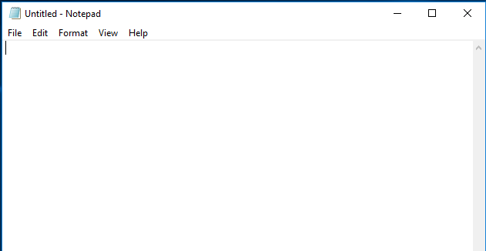
Step 2: Create new file: File->New File or Ctrl+N.
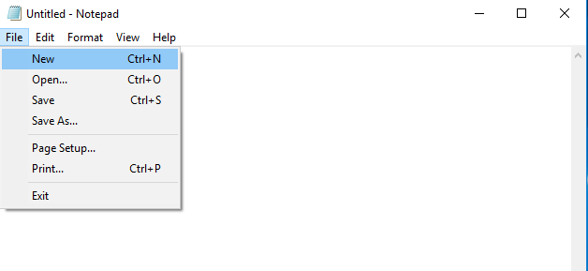
Step 3: Write HTML code in text editor.
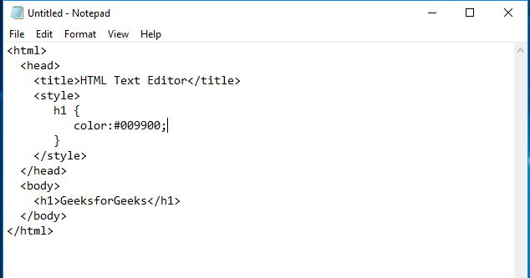
Step 4: Save the file with a suitable name of your choice and a .html extension.
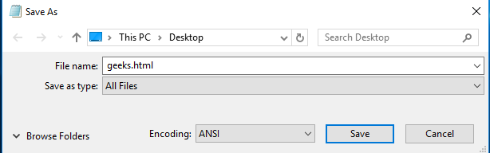
Step 5: Open the saved HTML file in your favorite browser (double-click on the file, or right-click - and choose "Open with").
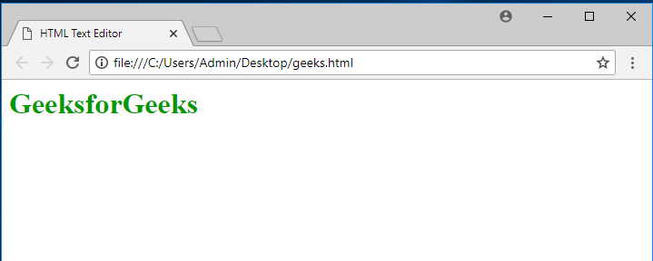

2. Brackets
Brackets is an open-source software primarily used for Web development. It provides live HTML, CSS, and JavaScript editing functionality. Similar to the Notepad editor, create a new file and save it with a .html extension to run the HTML file.
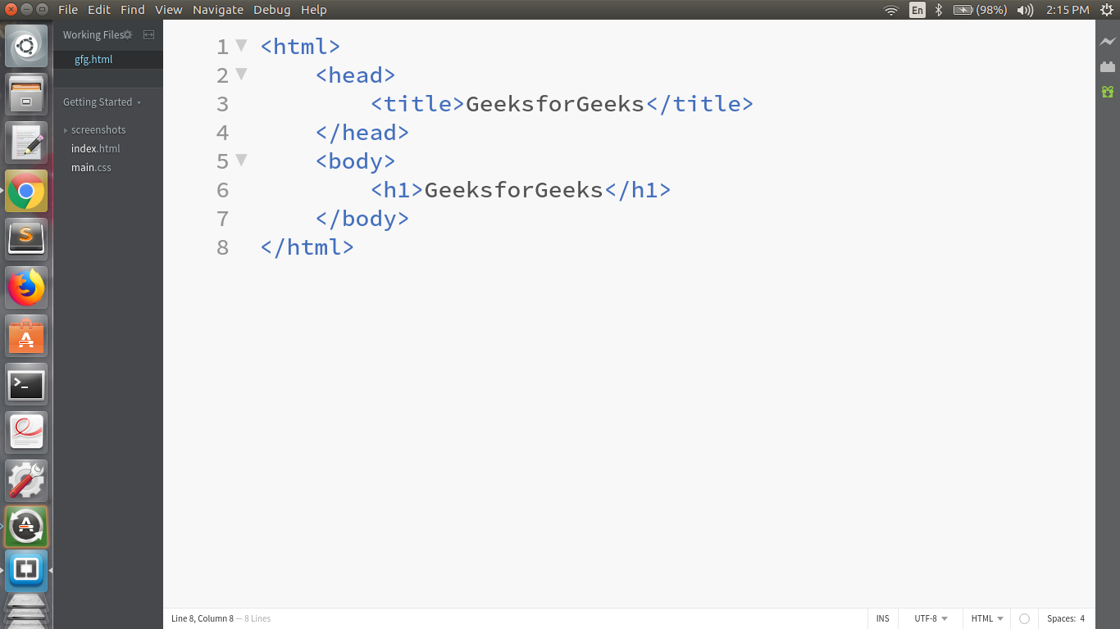

3. Sublime Text Editor
Sublime is a cross-platform code editor tool. It supports all markup languages and is used as an editor for HTML. Similar to the Notepad editor, create a new file and save it with a .html extension to run an HTML file.

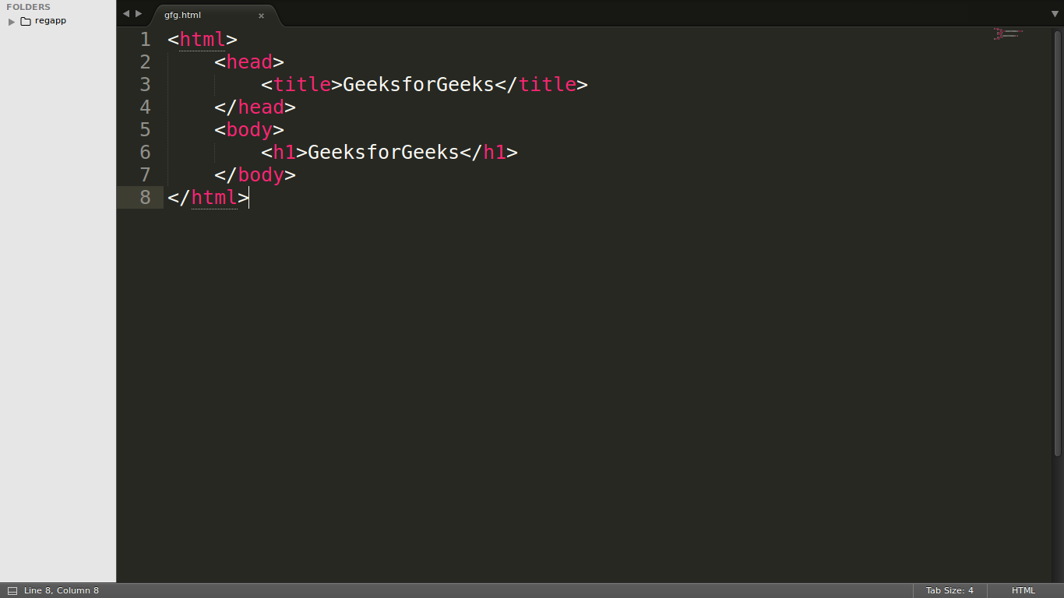

4. Atom
Atom is an open-source code editor tool for MAC, Linux, and Windows. We can use Atom to write and edit HTML code. Similar to the Notepad editor, create a new file and save it with a .html extension to run an HTML file.
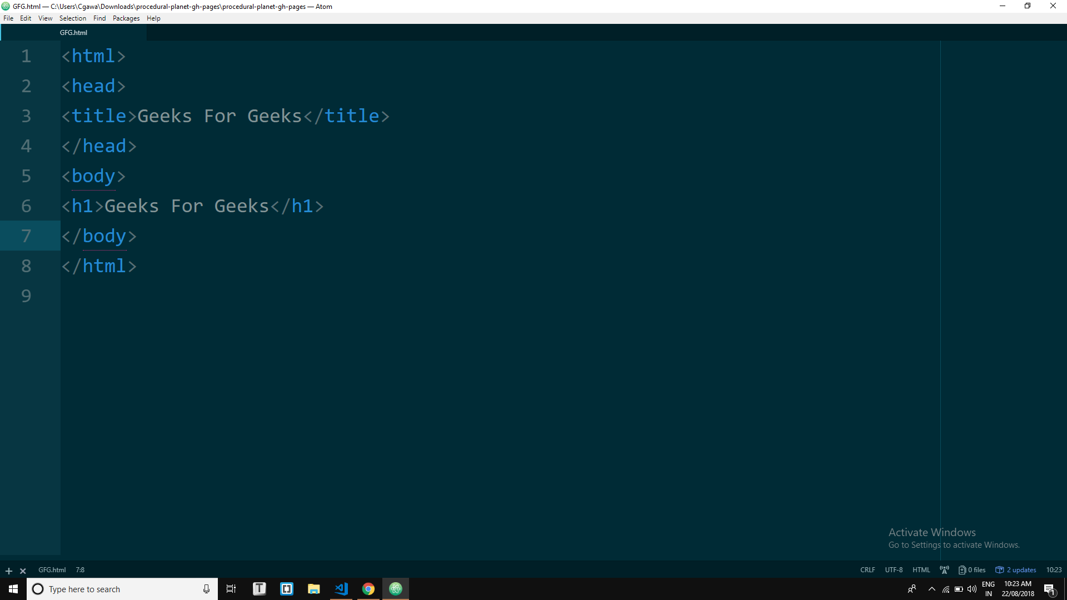

5. Visual Studio Code
It is one of the most popular code editors of today's generation. Many companies and software developers prefer this online HTML code editor.
Step 1: Open the VS code Editor and Install the Live Server. By clicking the extension button simply search live server on the search bar and download. Live server extension helps to run the code and display output.
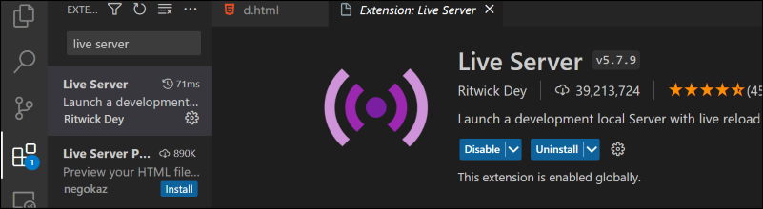
Step 2: Create a new File and save it with the .html extension and use the open live server button to click the right button.
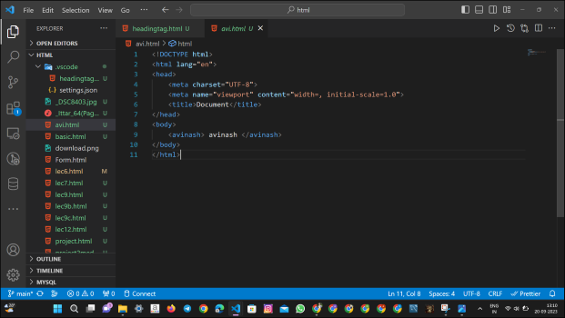

HTML (HyperText Markup Language) is the standard markup language used to create and structure web pages.
- It defines the layout of a webpage using elements and tags, allowing for the display of text, images, links, and multimedia content.
- As the foundation of nearly all websites, HTML is used in over 95% of all web pages today, making it an essential part of modern web development.
In this guide, we learn the basics of HTML, which includes HTML tags ( <h1>, <p>, <img>, etc), attributes, elements, and document structure which collectively form a working web page.

HTML Basic Document and Structure
Every HTML document begins with a document type declaration, setting the foundation for the webpage. This section introduces basic HTML tags that structure the page, such as <head>, <body>, and <title>. Although this is not mandatory, it is a good convention to start the document with the below-mentioned tag.
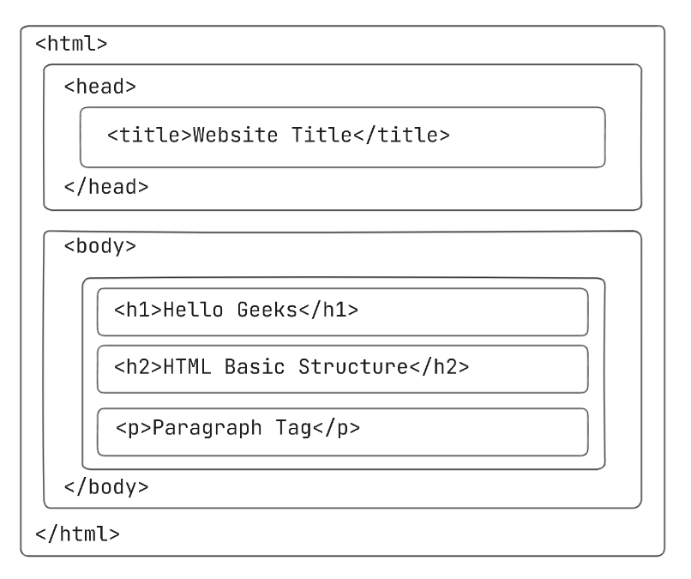HTML Structure
Below mentioned are the basic HTML tags that divide the whole page into various parts like head, body, etc.
Basic HTML Tags for Document Structure
Tags | Descriptions
<html> | Encloses the entire HTML document, serving as the root element for all HTML content.
<head> | Contains header information about the webpage, including title, meta tags, and linked stylesheets. It is part of the document's structure but is not displayed on the webpage.
<title> | Used within the <head> section to define the title of the HTML document. It appears in the browser tab or window and provides a brief description of the webpage's content.
<body> | Encloses the visible content of the webpage, such as text, images, audio, videos, and links. All elements within this tag are displayed on the actual webpage when viewed in a browser.
Example:
<!DOCTYPE html>
<html lang="en">
<head>
<meta charset="UTF-8">
<meta name="viewport"
content="width=device-width, initial-scale=1.0">
<title>HTML</title>
</head>
<body>
<!--Contents of the webpage-->
<p>GeeksforGeeks is a online study platform</p>
</body>
</html>
Code Overview:
- This HTML document defines a basic webpage with a responsive design using <meta> tags, ensuring it adjusts well to different devices.
- The content includes a paragraph <p> displaying "GeeksforGeeks is an online study platform," and the title "HTML" appears in the browser tab.

HTML Headings
The HTML heading tags are used to create headings for the content of a webpage. These tags are typically placed inside the body tag. HTML offers six heading tags, from <h1> to <h6>, each displaying the heading in a different font size.
Syntax:
<h1></h1>
<h2></h2>
<h3></h3>
<h4></h4>
<h5></h5>
<h6></h6>
<!DOCTYPE html>
<html lang="en">
<head>
<meta charset="UTF-8">
<meta name="viewport"
content="width=device-width, initial-scale=1.0">
<title>HTML</title>
</head>
<body>
<h1>Heading 1 (h1)</h1>
<h2>Heading 2 (h2)</h2>
<h3>Heading 3 (h3)</h3>
<h4>Heading 4 (h4)</h4>
<h5>Heading 5 (h5)</h5>
<h6>Heading 6 (h6)</h6>
</body>
</html>
Code Overview:
- This code displays six headings (<h1> to <h6>) on the webpage, with <h1> being the largest and most prominent and <h6> being the smallest.
- The headings are used to define text hierarchy and emphasize content based on importance.

HTML Paragraph and Break Elements
HTML <p> tags are used to write paragraph statements on a webpage. They start with the <p> tag and end with </p>. The HTML <br> tag is used to insert a single line break and does not require a closing tag. In HTML, the break tag is written as <br>.

Syntax:
// for Paragraph
<p> Content... </p>
// for Break
<br>
<!DOCTYPE html>
<html lang="en">
<head>
<meta charset="UTF-8">
<meta name="viewport"
content="width=device-width, initial-scale=1.0">
<title>HTML</title>
</head>
<body>
<p>
HTML stands for HyperText Markup Language.<br>
It is used to design web pages using a markup
language.<br>HTML is a combination of Hypertext
and Markup language.<br>Hypertext defines the
link between web pages.<br>A markup language
is used to define the text document within the
tag which defines the structure of web pages.
</p>
</body>
</html>
Code Overview:
- This HTML code uses a <p> tag to display a paragraph of text, providing an overview of what HTML is and its purpose.
- The <br> tags are used to insert line breaks, making the text more readable by separating each sentence onto a new line within the paragraph.

HTML Horizontal Line
The HTML <hr> tag is used to divide a page into sections by creating a horizontal line that spans from the left to the right side of the page. This is an empty tag and does not require a closing tag or any additional attributes.

Syntax:
<hr>
<!DOCTYPE html>
<html lang="en">
<head>
<meta charset="UTF-8">
<meta name="viewport"
content="width=device-width, initial-scale=1.0">
<title>HTML</title>
</head>
<body>
<p>
A Computer Science portal for geeks<br>
A Computer Science portal for geeks<br>
A Computer Science portal for geeks<br>
</p>
<hr>
<p>
A Computer Science portal for geeks<br>
A Computer Science portal for geeks<br>
A Computer Science portal for geeks<br>
</p>
<hr>
<p>
A Computer Science portal for geeks<br>
A Computer Science portal for geeks<br>
A Computer Science portal for geeks<br>
</p>
<hr>
</body>
</html>
Code Overview:
- <h1> to <h6> tags are used to define headings, with <h1> being the largest and <h6> the smallest.
- Each tag displays "Hello World!" in decreasing font sizes, illustrating the hierarchy of headings in HTML.

HTML Comments
HTML comments are annotations in your code that are not displayed in the browser. They are enclosed within <!-- and --> tags and are primarily used for documentation, explanation, or temporarily disabling code during debugging.

Syntax of HTML Comments
- Single-line comment:
<!-- This is a single-line comment -->
- Multi-line comment:
<!--
This is a multi-line comment
spanning multiple lines
-->
Example Usage of HTML Comments
<!DOCTYPE html>
<html lang="en">
<head>
<meta charset="UTF-8">
<meta name="viewport"
content="width=device-width, initial-scale=1.0">
<title>HTML</title>
</head>
<body>
<!-- This is a heading tag -->
<h1>Welcome to GeeksforGeeks</h1>
<!-- This is a paragraph tag -->
<p>Learn HTML, CSS, and JavaScript here.</p>
</body>
</html>
In this example, the comments provide context about the purpose of each HTML element.

Best Practices for Using HTML Comments
- Be concise and relevant: Write comments that explain the "why" behind the code in a brief and clear manner.
- Avoid over-commenting: Do not state the obvious. Let the code itself explain when possible.
- Keep comments up-to-date: Ensure comments reflect changes in the code to avoid confusion.

HTML Images
The <img> tag is used to insert an image into a webpage. The source of the image is specified within the src attribute, like this: <img src="source_of_image">.

Syntax:
<img src="geeks.png">
- This HTML code uses the <img> tag to display an image on a webpage.
- The src attribute specifies the URL of the image, which is loaded and displayed when the page is rendered in the browser.

View HTML Source Code
While checking a web page, you might want to see the HTML code behind it. Here we will see how you can view HTML source code for the entire page or a specific element.

1. View HTML Source Code of Entire Page
- To view the source code of a webpage press ctrl + u on the page, or right-click on the page and select the "view page source" option.
- This will open a new tab that shows the HTML source code for that entire page.

2. Inspect an HTML Element on a Page
- To check the HTML code for a specific element on a page, right-click on the page and select the "Inspect" option.
- This lets you see the HTML and CSS behind that element. You can also try making changes and see the changes.

Conclusion
Understanding HTML is the first step in becoming a web developer. By learning the basic tags and structure, you can create well-organized and functional web pages. The more you practice and experiment with HTML, the better you'll understand how to create interactive, engaging, and well-optimized websites.

